# MULTI LANGUAGE CALENDER AND DAIRY

*A*

*Mini Project Report*

*Submitted in partial fulfilment of the Requirements for the award of the Degree of*

### BACHELOR OF ENGINEERING

IN

### INFORMATION TECHNOLOGY

By

MOHAMMED ABU BAKAR SIDDIQ - 1602-19-737-083

SAJJANAPU SRICHARAN – 1602-19-737-112



### Department of Information Technology Vasavi College of Engineering (Autonomous) (Affiliated to Osmania University) Ibrahimbagh, Hyderabad-31

**2020**

**Vasavi College of Engineering (Autonomous) (Affiliated to Osmania University)**

**Hyderabad-500 031**

### Department of Information Technology



**DECLARATION BY THE CANDIDATE**

We, MOHAMMED ABU BAKAR SIDDIQ and SAJJANAPU SRICHARAN bearing hall ticket numbers, 1602-19-737-083 and 1602-19-737-112, hereby declare that the project report entitled “MULTI LANGUAGE CALENDER AND DAIRY” is submitted in partial fulfilment of the requirement for the award of the degree of Bachelor of Engineering in Information Technology.

This is a record of bonafide work carried out by us and the results embodied in this project report have not been submitted to any other university or institute for the award of any other

degree or diploma.

MD ABU BAKAR

1602-19-737-083

SAJJANAPU SRICHARAN

1602-19-737-112

(Faculty In-Charge) (Head.Dept IT)

# Acknowledgements

The satisfaction that accompanies the successful completion of this project would not be in complete without the mention of the people who made it possible, without whose constant guidance and encouragement would have made efforts go in vain. We consider ourselves privileged to express gratitude and respect towards all those who guided us through the completion of this project.

We convey thanks to my project guide Mrs.Prasanna of Information technology Department for providing encouragement, constant support and guidance which was of a great help to complete this project successfully.

Last but not the least, we wish to thank our parents for financing our studies in this privileged Vasavi College of Engineering as well as for constantly encouraging us to learn engineering. Their personal sacrifice in providing this opportunity to learn engineering is gratefully acknowledged.

# Abstract

As there many applications for Calenders and Diaries But It would always be better if calenders itself contains diary and if the calender can be viewed in different languages than that’s a plus plus. So, we have come up with an idea of developing an programme which can be used as an calender and as a personal diary. And our calender can display the calender in different languages .As personal diaries are very private, so our diary is password protected. There are many features like editing the existing diary , deleting , adding new one , and changing password etc.

Our app is very handy for a lot of people.

# Table of contents

|  |  |
| --- | --- |
| **Topic** | **Page Number** |
| **Introduction** | **6** |
| **Technology** | **8** |
| **Proposed Work** | **9** |
| **Results** | **99** |
| **Test Plan** | **105** |
| **Conclusions and Future work** | **105** |
| **References** | **106** |

## INTRODUCTION

The project “Multi Language Calender And Dairy” can be used by multiple users but only one user can use dairy but other users can view the calender in multiple languages of any year. The user can who uses dairy first need to set up password then he/her can use different functions available for writing new dairy with specified date time and location . He can used it for editing, viewing,deleting and changing password.

Registered User:

1.View Calender in Multiple Languages

2.Write Dairy

3.Edit dairy

4.View Dairy

5.Delete Dairy

6.Change Password

Other Users:

1.View Calender In Different Languages

Registered User:

The registered user at first need to set his password then he can use it for writing dairy , viewing , editing , deleting and changing password and for viewing the calender in multiple languages.

For writing the dairy the user doesn’t require any password . After selecting add dairy the user need to add date , time and location.

For viewing the dairy the user need to select the view diary option then he need to enter the password the user gets only 3 attempts if its incorrect the program to main menu. Then after entering the password the user need to select specified date and time for viewing it.

For editing the dairy the user need to enter the password then , he needs to select the specific date and time for editing it.

For deleting the dairy the user needs to enter the password and then the specified date and time to delete

For changing the password the user needs to first needs to enter the old password then he needs to enter the new password and then confirm it .

## TECHNOLOGY:

All compute software needs certain hardware components or other software components resources to be present. In order for computesr to used efficiently these are the primary requestisites. There are two different categories of this section.

### Software Requirements:

Software requirements mainly share out with defining the software resource requirements that need to be installed on a computer to provide optimal functioning of a particular application. Therse conditions are not included in the software installation package and need to be installed separately.

In order to use Multi Language Calender And Dairy the following are the prerequisties,

* + - 1. Operating System – Windows 7 and above
      2. C Compiler – GNU Compiler
      3. Editor – Any basic editor is preferable (Example: Notepadd++)

### Hardware Requirements:

Hardware requirements refer to the common set requirements defined by any operating system or software application and are usually the physical computer resources. In this section we basically deal with primary memory, secondary memory, processing power.

In order to use Parking Lot Management System one should have the following,

* + - 1. Processor – Any Dual Core or higher end
      2. Memory – 2GB

## PROPOSED WORK

### Design

USER: OTHER USERS:

1.View Calender 1.View Calender

2.View Diary

3.Edit Diary DIARY DATABASE:

4.Add Diary 1.View Dairy

5.Delete Diary 2.Edit Dairy

6.Change Password 3.Add Dairy

* 1. **User Case Diagram and descriptions for all the use cases**

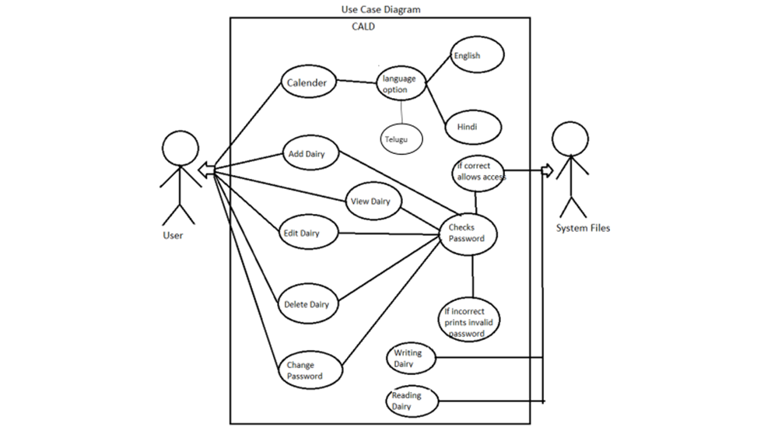

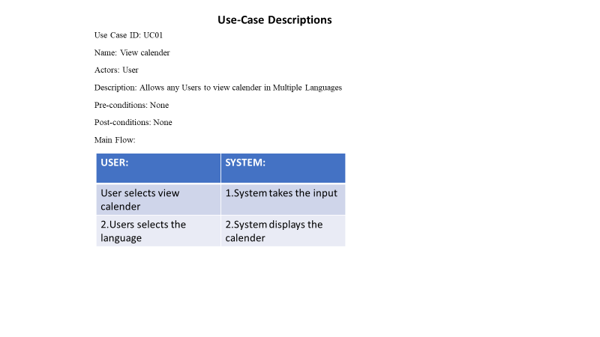

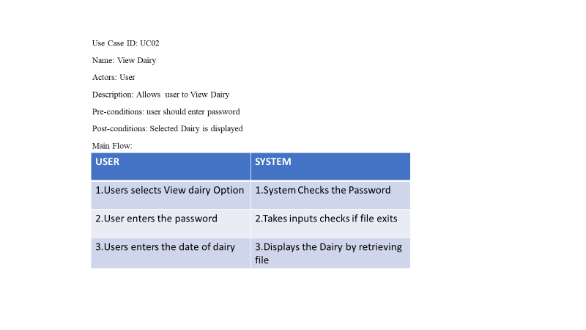

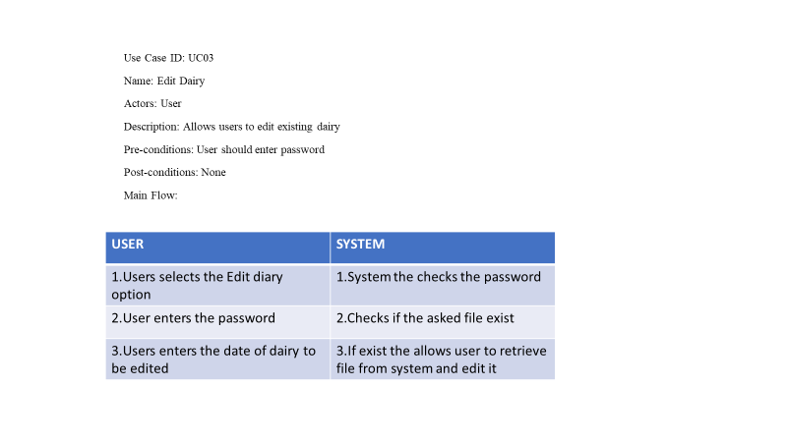

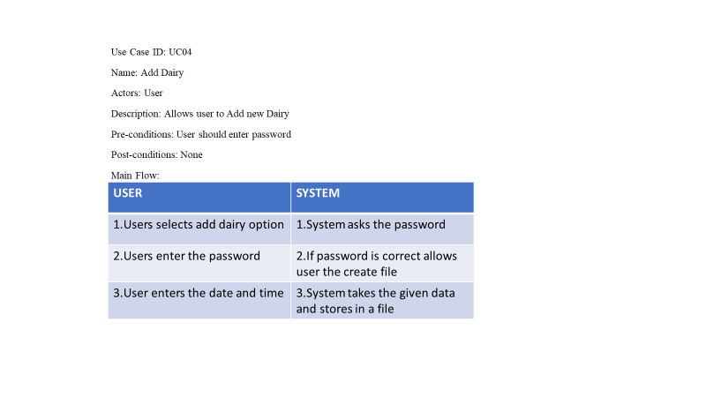

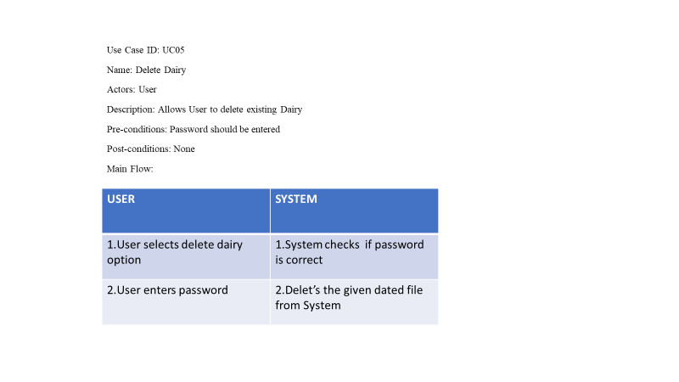

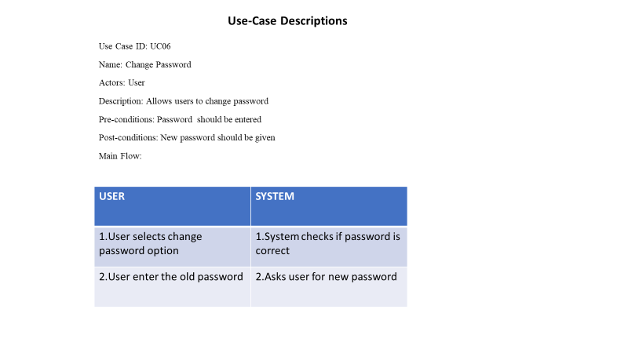

**b . IMPLEMENTATION**

**#include<stdio.h>**

**#include<stdlib.h>**

**#include<conio.h>**

**#include<string.h>**

**int password();**

**void addrecord();**

**void viewrecord();**

**void editrecord();**

**void editpassword();**

**void deleterecord();**

**int calender();**

**struct record**

**{**

**char time[6];**

**char name[30];**

**char place[25];**

**char duration[10];**

**char note[500];**

**} ;**

**int main()**

**{**

**int ch,k;**

**printf("\n\n\t***********************************\n");**

**printf("\t*PASSWORD PROTECTED PERSONAL DIARY \t*\n");**

**printf("\t* AND CALENDER \t*\n");**

**printf("\t***********************************");**

**while(1)**

**{**

**printf("\n\n\tMAIN MENU:");**

**printf("\n\tCALENDER\t[1]");**

**printf("\n\tADD RECORD\t[2]");**

**printf("\n\tVIEW RECORD\t[3]");**

**printf("\n\tEDIT RECORD\t[4]");**

**printf("\n\tDELETE RECORD\t[5]");**

**printf("\n\tEDIT PASSWORD\t[6]");**

**printf("\n\tEXIT\t\t[7]");**

**printf("\n\n\tENTER YOUR CHOICE:");**

**scanf("%d",&ch);**

**switch(ch)**

**{**

**case 1:**

**k=calender();**

**break;**

**case 2:**

**addrecord();**

**break;**

**case 3:**

**viewrecord();**

**break;**

**case 4:**

**editrecord();**

**break;**

**case 5:**

**deleterecord();**

**break;**

**case 6:**

**editpassword();**

**break;**

**case 7:**

**printf("\n\n\t\tTHANK YOU FOR USING THE SOFTWARE ");**

**getch();**

**exit(0);**

**default:**

**printf("\nYOU ENTERED WRONG CHOICE..");**

**printf("\nPRESS ANY KEY TO TRY AGAIN");**

**getch();**

**break;**

**}**

**system("cls");**

**}**

**return 0;**

**}**

**void addrecord( )**

**{**

**system("cls");**

**FILE *fp ;**

**char another = 'Y' ,time[10];**

**struct record e ;**

**char filename[15];**

**int choice;**

**printf("\n\n\t\t***************************\n");**

**printf("\t\t* WELCOME TO THE ADD MENU *");**

**printf("\n\t\t***************************\n\n");**

**printf("\n\n\tENTER DATE OF YOUR RECORD:[yyyy-mm-dd]:");**

**fflush(stdin);**

**gets(filename);**

**fp = fopen (filename, "ab+" ) ;**

**if ( fp == NULL )**

**{**

**fp=fopen(filename,"wb+");**

**if(fp==NULL)**

**{**

**printf("\nSYSTEM ERROR...");**

**printf("\nPRESS ANY KEY TO EXIT");**

**getch();**

**return ;**

**}**

**}**

**while ( another == 'Y'|| another=='y' )**

**{**

**choice=0;**

**fflush(stdin);**

**printf ( "\n\tENTER TIME:[hh:mm]:");**

**scanf("%s",time);**

**rewind(fp);**

**while(fread(&e,sizeof(e),1,fp)==1)**

**{**

**if(strcmp(e.time,time)==0)**

**{**

**printf("\n\tTHE RECORD ALREADY EXISTS.\n");**

**choice=1;**

**}**

**}**

**if(choice==0)**

**{**

**strcpy(e.time,time);**

**printf("\tENTER NAME:");**

**fflush(stdin);**

**gets(e.name);**

**fflush(stdin);**

**printf("\tENTER PLACE:");**

**gets(e.place);**

**fflush(stdin);**

**printf("\tENTER DURATION:");**

**gets(e.duration);**

**fflush(stdin);**

**printf("\tNOTE:");**

**gets(e.note);**

**fwrite ( &e, sizeof ( e ), 1, fp ) ;**

**printf("\nYOUR RECORD IS ADDED...\n");**

**}**

**printf ( "\n\tADD ANOTHER RECORD...(Y/N) " ) ;**

**fflush ( stdin ) ;**

**another = getchar( ) ;**

**}**

**fclose ( fp ) ;**

**printf("\n\n\tPRESS ANY KEY TO EXIT...");**

**getch();**

**}**

**void viewrecord( )**

**{**

**FILE *fpte ;**

**system("cls");**

**struct record customer ;**

**char time[6],choice,filename[14];**

**int ch;**

**printf("\n\n\t\t*******************************\n");**

**printf("\t\t* HERE IS THE VIEWING MENU *");**

**printf("\n\t\t*******************************\n\n");**

**choice=password();**

**if(choice!=0)**

**{**

**return ;**

**}**

**do**

**{**

**printf("\n\tENTER THE DATE OF RECORD TO BE VIEWED:[yyyy-mm-dd]:");**

**fflush(stdin);**

**gets(filename);**

**fpte = fopen ( filename, "rb" ) ;**

**if ( fpte == NULL )**

**{**

**puts ( "\nTHE RECORD DOES NOT EXIST...\n" ) ;**

**printf("PRESS ANY KEY TO EXIT...");**

**getch();**

**return ;**

**}**

**system("cls");**

**printf("\n\tHOW WOULD YOU LIKE TO VIEW:\n");**

**printf("\n\t1.WHOLE RECORD OF THE DAY.");**

**printf("\n\t2.RECORD OF FIX TIME.");**

**printf("\n\t\tENTER YOUR CHOICE:");**

**scanf("%d",&ch);**

**switch(ch)**

**{**

**case 1:**

**printf("\nTHE WHOLE RECORD FOR %s IS:",filename);**

**while ( fread ( &customer, sizeof ( customer ), 1, fpte ) == 1 )**

**{**

**printf("\n");**

**printf("\nTIME: %s",customer.time);**

**printf("\nMEETING WITH: %s",customer.name);**

**printf("\nMEETING AT: %s",customer.place);**

**printf("\nDURATION: %s",customer.duration);**

**printf("\nNOTE: %s",customer.note);**

**printf("\n");**

**}**

**break;**

**case 2:**

**fflush(stdin);**

**printf("\nENTER TIME:[hh:mm]:");**

**gets(time);**

**while ( fread ( &customer, sizeof ( customer ), 1, fpte ) == 1 )**

**{**

**if(strcmp(customer.time,time)==0)**

**{**

**printf("\nYOUR RECORD IS:");**

**printf("\nTIME: %s",customer.time);**

**printf("\nMEETING WITH: %s",customer.name);**

**printf("\nMEETING AT: %s",customer.place);**

**printf("\nDUARATION: %s",customer.duration);**

**printf("\nNOTE: %s",customer.note);**

**}**

**}**

**break;**

**default:**

**printf("\nYOU TYPED SOMETHING ELSE...\n");**

**break;**

**}**

**printf("\n\nWOULD YOU LIKE TO CONTINUE VIEWING...(Y/N):");**

**fflush(stdin);**

**scanf("%c",&choice);**

**}**

**while(choice=='Y'||choice=='y');**

**fclose ( fpte ) ;**

**return ;**

**}**

**void editrecord()**

**{**

**system("cls");**

**FILE *fpte ;**

**struct record customer ;**

**char time[6],choice,filename[14];**

**int num,count=0;**

**printf("\n\n\t\t*******************************\n");**

**printf("\t\t* WELCOME TO THE EDITING MENU *");**

**printf("\n\t\t*******************************\n\n");**

**choice=password();**

**if(choice!=0)**

**{**

**return ;**

**}**

**do**

**{**

**printf("\n\tENTER THE DATE OF RECORD TO BE EDITED:[yyyy-mm-dd]:");**

**fflush(stdin);**

**gets(filename);**

**printf("\n\tENTER TIME:[hh:mm]:");**

**gets(time);**

**fpte = fopen ( filename, "rb+" ) ;**

**if ( fpte == NULL )**

**{**

**printf( "\nRECORD DOES NOT EXISTS:" ) ;**

**printf("\nPRESS ANY KEY TO GO BACK");**

**getch();**

**return;**

**}**

**while ( fread ( &customer, sizeof ( customer ), 1, fpte ) == 1 )**

**{**

**if(strcmp(customer.time,time)==0)**

**{**

**printf("\nYOUR OLD RECORD WAS AS:");**

**printf("\nTIME: %s",customer.time);**

**printf("\nMEETING WITH: %s",customer.name);**

**printf("\nMEETING AT: %s",customer.place);**

**printf("\nDURATION: %s",customer.duration);**

**printf("\nNOTE: %s",customer.note);**

**printf("\n\n\t\tWHAT WOULD YOU LIKE TO EDIT..");**

**printf("\n1.TIME.");**

**printf("\n2.MEETING PERSON.");**

**printf("\n3.MEETING PLACE.");**

**printf("\n4.DURATION.");**

**printf("\n5.NOTE.");**

**printf("\n6.WHOLE RECORD.");**

**printf("\n7.GO BACK TO MAIN MENU.");**

**do**

**{**

**printf("\n\tENTER YOUR CHOICE:");**

**fflush(stdin);**

**scanf("%d",&num);**

**fflush(stdin);**

**switch(num)**

**{**

**case 1:**

**printf("\nENTER THE NEW DATA:");**

**printf("\nNEW TIME:[hh:mm]:");**

**gets(customer.time);**

**break;**

**case 2:**

**printf("\nENTER THE NEW DATA:");**

**printf("\nNEW MEETING PERSON:");**

**gets(customer.name);**

**break;**

**case 3:**

**printf("\nENTER THE NEW DATA:");**

**printf("\nNEW MEETING PLACE:");**

**gets(customer.place);**

**break;**

**case 4:**

**printf("\nENTER THE NEW DATA:");**

**printf("\nDURATION:");**

**gets(customer.duration);**

**break;**

**case 5:**

**printf("ENTER THE NEW DATA:");**

**printf("\nNOTE:");**

**gets(customer.note);**

**break;**

**case 6:**

**printf("\nENTER THE NEW DATA:");**

**printf("\nNEW TIME:[hh:mm]:");**

**gets(customer.time);**

**printf("\nNEW MEETING PERSON:");**

**gets(customer.name);**

**printf("\nNEW MEETING PLACE:");**

**gets(customer.place);**

**printf("\nDURATION:");**

**gets(customer.duration);**

**printf("\nNOTE:");**

**gets(customer.note);**

**break;**

**case 7:**

**printf("\nPRESS ANY KEY TO GO BACK...\n");**

**getch();**

**return ;**

**break;**

**default:**

**printf("\nYOU TYPED SOMETHING ELSE...TRY AGAIN\n");**

**break;**

**}**

**}**

**while(num<1||num>8);**

**fseek(fpte,sizeof(customer),SEEK_CUR);**

**fwrite(&customer,sizeof(customer),1,fpte);**

**fseek(fpte,sizeof(customer),SEEK_CUR);**

**fread(&customer,sizeof(customer),1,fpte);**

**choice=5;**

**break;**

**}**

**}**

**if(choice==5)**

**{**

**system("cls");**

**printf("\n\t\tEDITING COMPLETED...\n");**

**printf("--------------------\n");**

**printf("THE NEW RECORD IS:\n");**

**printf("--------------------\n");**

**printf("\nTIME: %s",customer.time);**

**printf("\nMEETING WITH: %s",customer.name);**

**printf("\nMEETING AT: %s",customer.place);**

**printf("\nDURATION: %s",customer.duration);**

**printf("\nNOTE: %s",customer.note);**

**fclose(fpte);**

**printf("\n\n\tWOULD YOU LIKE TO EDIT ANOTHER RECORD.(Y/N)");**

**scanf("%c",&choice);**

**count++;**

**}**

**else**

**{**

**printf("\nTHE RECORD DOES NOT EXIST::\n");**

**printf("\nWOULD YOU LIKE TO TRY AGAIN...(Y/N)");**

**scanf("%c",&choice);**

**}**

**}**

**while(choice=='Y'||choice=='y');**

**fclose ( fpte ) ;**

**if(count==1)**

**printf("\n%d FILE IS EDITED...\n",count);**

**else if(count>1)**

**printf("\n%d FILES ARE EDITED..\n",count);**

**else**

**printf("\nNO FILES EDITED...\n");**

**printf("\tPRESS ENTER TO EXIT EDITING MENU.");**

**getch();**

**}**

**int password()**

**{**

**char pass[15]= {0},check[15]= {0},ch;**

**FILE *fpp;**

**int i=0,j;**

**printf("::FOR SECURITY PURPOSE::");**

**printf("::ONLY THREE TRIALS ARE ALLOWED::");**

**for(j=0; j<3; j++)**

**{**

**i=0;**

**printf("\n\n\tENTER THE PASSWORD:");**

**pass[0]=getch();**

**while(pass[i]!='\r')**

**{**

**if(pass[i]=='\b')**

**{**

**i--;**

**printf("\b");**

**printf(" ");**

**printf("\b");**

**pass[i]=getch();**

**}**

**else**

**{**

**printf("*");**

**i++;**

**pass[i]=getch();**

**}**

**}**

**pass[i]='\0';**

**fpp=fopen("SE","r");**

**if (fpp==NULL)**

**{**

**printf("\nERROR WITH THE SYSTEM FILE...[FILE MISSING]\n");**

**getch();**

**return 1;**

**}**

**else**

**i=0;**

**while(1)**

**{**

**ch=fgetc(fpp);**

**if(ch==EOF)**

**{**

**check[i]='\0';**

**break;**

**}**

**check[i]=ch-5;**

**i++;**

**}**

**if(strcmp(pass,check)==0)**

**{**

**printf("\n\n\tACCESS GRANTED...\n");**

**return 0;**

**}**

**else**

**{**

**printf("\n\n\tWRONG PASSWORD..\n\n\tACCESS DENIED...\n");**

**}**

**}**

**printf("\n\n\t::YOU ENTERED WRONG PASSWORD::YOU ARE NOT ALLOWED TO ACCESS ANY FILE::\n\n\tPRESS ANY KEY TO GO BACK...");**

**getch();**

**return 1;**

**}**

**void editpassword()**

**{**

**system("cls");**

**printf("\n");**

**char pass[15]= {0},confirm[15]= {0},ch;**

**int choice,i,check;**

**FILE *fp;**

**fp=fopen("SE","rb");**

**if(fp==NULL)**

**{**

**fp=fopen("SE","wb");**

**if(fp==NULL)**

**{**

**printf("SYSTEM ERROR...");**

**getch();**

**return ;**

**}**

**fclose(fp);**

**printf("\nSYSTEM RESTORED...\nYOUR PASSWORD IS 'ENTER'\n PRESS ENTER TO CHANGE PASSWORD\n\n");**

**getch();**

**}**

**fclose(fp);**

**check=password();**

**if(check==1)**

**{**

**return ;**

**}**

**do**

**{**

**if(check==0)**

**{**

**i=0;**

**choice=0;**

**printf("\n\n\tENTER THE NEW PASSWORD:");**

**fflush(stdin);**

**pass[0]=getch();**

**while(pass[i]!='\r')**

**{**

**if(pass[i]=='\b')**

**{**

**i--;**

**printf("\b");**

**printf(" ");**

**printf("\b");**

**pass[i]=getch();**

**}**

**else**

**{**

**printf("*");**

**i++;**

**pass[i]=getch();**

**}**

**}**

**pass[i]='\0';**

**i=0;**

**printf("\n\tCONFIRM PASSWORD:");**

**confirm[0]=getch();**

**while(confirm[i]!='\r')**

**{**

**if(confirm[i]=='\b')**

**{**

**i--;**

**printf("\b");**

**printf(" ");**

**printf("\b");**

**confirm[i]=getch();**

**}**

**else**

**{**

**printf("*");**

**i++;**

**confirm[i]=getch();**

**}**

**}**

**confirm[i]='\0';**

**if(strcmp(pass,confirm)==0)**

**{**

**fp=fopen("SE","wb");**

**if(fp==NULL)**

**{**

**printf("\n\t\tSYSTEM ERROR");**

**getch();**

**return ;**

**}**

**i=0;**

**while(pass[i]!='\0')**

**{**

**ch=pass[i];**

**putc(ch+5,fp);**

**i++;**

**}**

**putc(EOF,fp);**

**fclose(fp);**

**}**

**else**

**{**

**printf("\n\tTHE NEW PASSWORD DOES NOT MATCH.");**

**choice=1;**

**}**

**}**

**}**

**while(choice==1);**

**printf("\n\n\tPASSWORD CHANGED...\n\n\tPRESS ANY KEY TO GO BACK...");**

**getch();**

**}**

**void deleterecord( )**

**{**

**system("cls");**

**FILE *fp,*fptr ;**

**struct record file ;**

**char filename[15],another = 'Y' ,time[10];;**

**int choice,check;**

**printf("\n\n\t\t*************************\n");**

**printf("\t\t* WELCOME TO DELETE MENU*");**

**printf("\n\t\t*************************\n\n");**

**check = password();**

**if(check==1)**

**{**

**return ;**

**}**

**while ( another == 'Y' )**

**{**

**printf("\n\n\tHOW WOULD YOU LIKE TO DELETE.");**

**printf("\n\n\t#DELETE WHOLE RECORD\t\t\t[1]");**

**printf("\n\t#DELETE A PARTICULAR RECORD BY TIME\t[2]");**

**do**

**{**

**printf("\n\t\tENTER YOU CHOICE:");**

**scanf("%d",&choice);**

**switch(choice)**

**{**

**case 1:**

**printf("\n\tENTER THE DATE OF RECORD TO BE DELETED:[yyyy-mm-dd]:");**

**fflush(stdin);**

**gets(filename);**

**fp = fopen (filename, "wb" ) ;**

**if ( fp == NULL )**

**{**

**printf("\nTHE FILE DOES NOT EXISTS");**

**printf("\nPRESS ANY KEY TO GO BACK.");**

**getch();**

**return ;**

**}**

**fclose(fp);**

**remove(filename);**

**printf("\nDELETED SUCCESFULLY...");**

**break;**

**case 2:**

**printf("\n\tENTER THE DATE OF RECORD:[yyyy-mm-dd]:");**

**fflush(stdin);**

**gets(filename);**

**fp = fopen (filename, "rb" ) ;**

**if ( fp == NULL )**

**{**

**printf("\nTHE FILE DOES NOT EXISTS");**

**printf("\nPRESS ANY KEY TO GO BACK.");**

**getch();**

**return ;**

**}**

**fptr=fopen("temp","wb");**

**if(fptr==NULL)**

**{**

**printf("\nSYSTEM ERROR");**

**printf("\nPRESS ANY KEY TO GO BACK");**

**getch();**

**return ;**

**}**

**printf("\n\tENTER THE TIME OF RECORD TO BE DELETED:[hh:mm]:");**

**fflush(stdin);**

**gets(time);**

**while(fread(&file,sizeof(file),1,fp)==1)**

**{**

**if(strcmp(file.time,time)!=0)**

**fwrite(&file,sizeof(file),1,fptr);**

**}**

**fclose(fp);**

**fclose(fptr);**

**remove(filename);**

**rename("temp",filename);**

**printf("\nDELETED SUCCESFULLY...");**

**break;**

**default:**

**printf("\n\tYOU ENTERED WRONG CHOICE");**

**break;**

**}**

**}**

**while(choice<1||choice>2);**

**printf("\n\tDO YOU LIKE TO DELETE ANOTHER RECORD.(Y/N):");**

**fflush(stdin);**

**scanf("%c",&another);**

**}**

**printf("\n\n\tPRESS ANY KEY TO EXIT...");**

**getch();**

**}**

**int leapyear(int x){**

**if(x%4==0){**

**if(x%100==0){**

**if(x%400==0){**

**return 1;**

**}**

**else{**

**return 0;**

**}**

**}**

**else{**

**return 1;**

**}**

**}**

**else{**

**return 0;**

**}**

**}**

**int calender()**

**{**

**int s;**

**int f,k,m,d,c;**

**int day,month,year,a1,a2,a3,res,yr,i,j,z,b;**

**while(s!=0)**

**{**

**printf("Enter 1 for English calendar:\nEnter 2 for Telugu calendar:\nEnter 0 to exit:\n");**

**scanf("%d",&s);**

**if(s==1){**

**printf("\nYear:");**

**scanf("%d",&year);**

**printf("\nMonth:");**

**scanf("%d",&month);**

**printf("\n\n\t");**

**if(month==1){**

**printf("\tJanuary");**

**}**

**else if(month==2){**

**printf("\tFebruary");**

**}**

**else if(month==3){**

**printf("\tMarch");**

**}**

**else if(month==4){**

**printf("\tApril");**

**}**

**else if(month==5){**

**printf("\tMay");**

**}**

**else if(month==6){**

**printf("\tJune");**

**}**

**else if(month==7){**

**printf("\tJuly");**

**}**

**else if(month==8){**

**printf("\tAugust");**

**}**

**else if(month==9){**

**printf("\tSeptember");**

**}**

**else if(month==10){**

**printf("\tOctober");**

**}**

**else if(month==11){**

**printf("\tNovember");**

**}**

**else if(month==12){**

**printf("\tDecember");**

**}**

**printf(" %d\n\n",year);**

**printf(" SUN MON TUE WED THU FRI SAT\n\n");**

**if(month==1){**

**m=11;**

**d=(year%100)-1;**

**}**

**else if(month==2){**

**m=12;**

**d=(year%100)-1;**

**}**

**else{**

**m=month-2;**

**d=year%100;**

**}**

**c=year/100;**

**a1=(13*m-1)/5;**

**a2=d/4;**

**a3=c/4;**

**f=1+a1+d+a2+a3-2*c;**

**if(f>=0){**

**res=f%7;**

**}**

**else {**

**res=(f%7)+7;**

**}**

**z=1;**

**for(i=0;i<6;i++){**

**if(i==0){**

**for(j=0;j<7;j++){**

**if(j==res){**

**printf(" %3d ",z);**

**res++;**

**z++;**

**}**

**else{**

**printf(" ");**

**}**

**}**

**printf("\n\n");**

**}**

**else{**

**for(b=0;b<7;b++){**

**if(1==leapyear(year)){**

**if(z==30 && m==12){**

**break;**

**}**

**}**

**else{**

**if(z==29 && m==12){**

**break;**

**}**

**}**

**if(z==31 && (m==2 || m==4 || m==7 || m==9)){**

**break;**

**}**

**if(z==32){**

**break;**

**}**

**printf(" %3d ",z);**

**z++;**

**}**

**printf("\n\n");**

**}**

**}**

**}**

**else if(s==2){**

**printf("\nYear:");**

**scanf("%d",&year);**

**printf("\nMonth:");**

**scanf("%d",&month);**

**printf("\n\n\t");**

**if(month==1){**

**printf("\tMAAKHAMU");**

**}**

**else if(month==2){**

**printf("\tPHAALGUNAMU");**

**}**

**else if(month==3){**

**printf("\tCHAITHRAMU");**

**}**

**else if(month==4){**

**printf("\tVAISAAKHAMU");**

**}**

**else if(month==5){**

**printf("\tJYESHTTA");**

**}**

**else if(month==6){**

**printf("\tAASHAADHAMU");**

**}**

**else if(month==7){**

**printf("\tSRAAVANAMU");**

**}**

**else if(month==8){**

**printf("\tBHAADHRAPADAMU");**

**}**

**else if(month==9){**

**printf("\tAASVEEYUJAMU");**

**}**

**else if(month==10){**

**printf("\tKAARTHIKAMU");**

**}**

**else if(month==11){**

**printf("\tMAARGASEERSHAMU");**

**}**

**else if(month==12){**

**printf("\tPUSHYAMU");**

**}**

**printf(" %d\n\n",year);**

**printf(" AAD SOM MAN BUD GUR SUK SAN\n\n");**

**yr=year+594;**

**if(month==12){**

**m=1;**

**d=yr%100;**

**}**

**else{**

**m=month+1;**

**d=(yr%100)-1;**

**}**

**c=yr/100;**

**if(m==1){**

**a1=0;**

**}**

**else if(m>=2 && m<=7){**

**a1=3*m-4;**

**}**

**else{**

**a1=2*m+3;**

**}**

**a2=d/4;**

**a3=c/4;**

**f=a1+d+a2+a3+4-2*c;**

**if(f%7>=0){**

**res=f%7;**

**}**

**else{**

**res=(f%7)+7;**

**}**

**z=1;**

**for(i=0;i<6;i++){**

**if(i==0){**

**for(j=0;j<7;j++){**

**if(j==res){**

**printf(" %3d ",z);**

**res++;**

**z++;**

**}**

**else{**

**printf(" ");**

**}**

**}**

**printf("\n\n");**

**}**

**else{**

**for(b=0;b<7;b++){**

**if(1==leapyear(yr)){**

**if(z==32 && m==12){**

**break;**

**}**

**}**

**else{**

**if(z==31 && m==12){**

**break;**

**}**

**}**

**if(z==31 && (m==1 || (m>=7&&m<=11))){**

**break;**

**}**

**if(z==32){**

**break;**

**}**

**printf(" %3d ",z);**

**z++;**

**}**

**printf("\n\n");**

**}**

**}**

**}**

**}return 0;**

**}**

### Testing

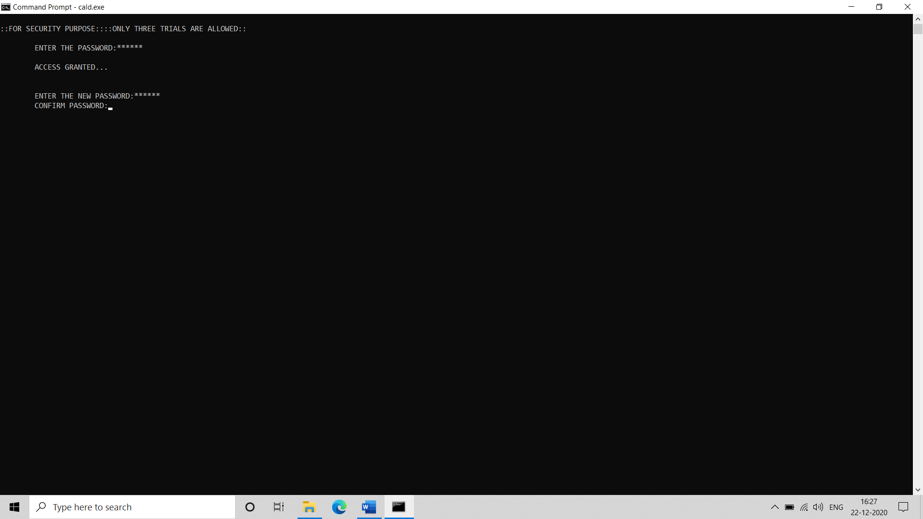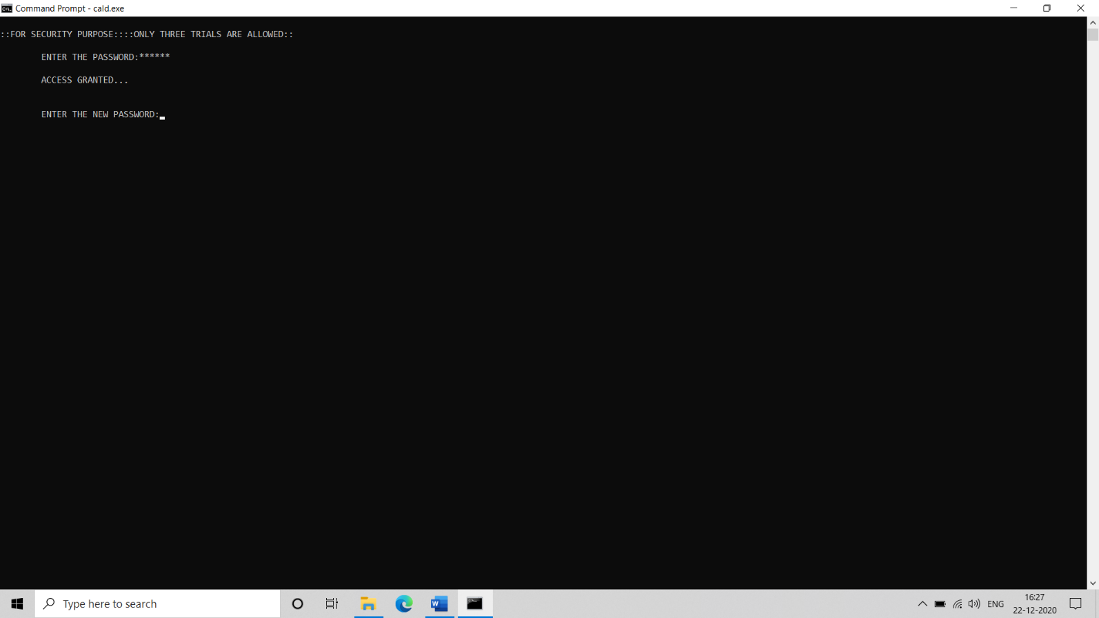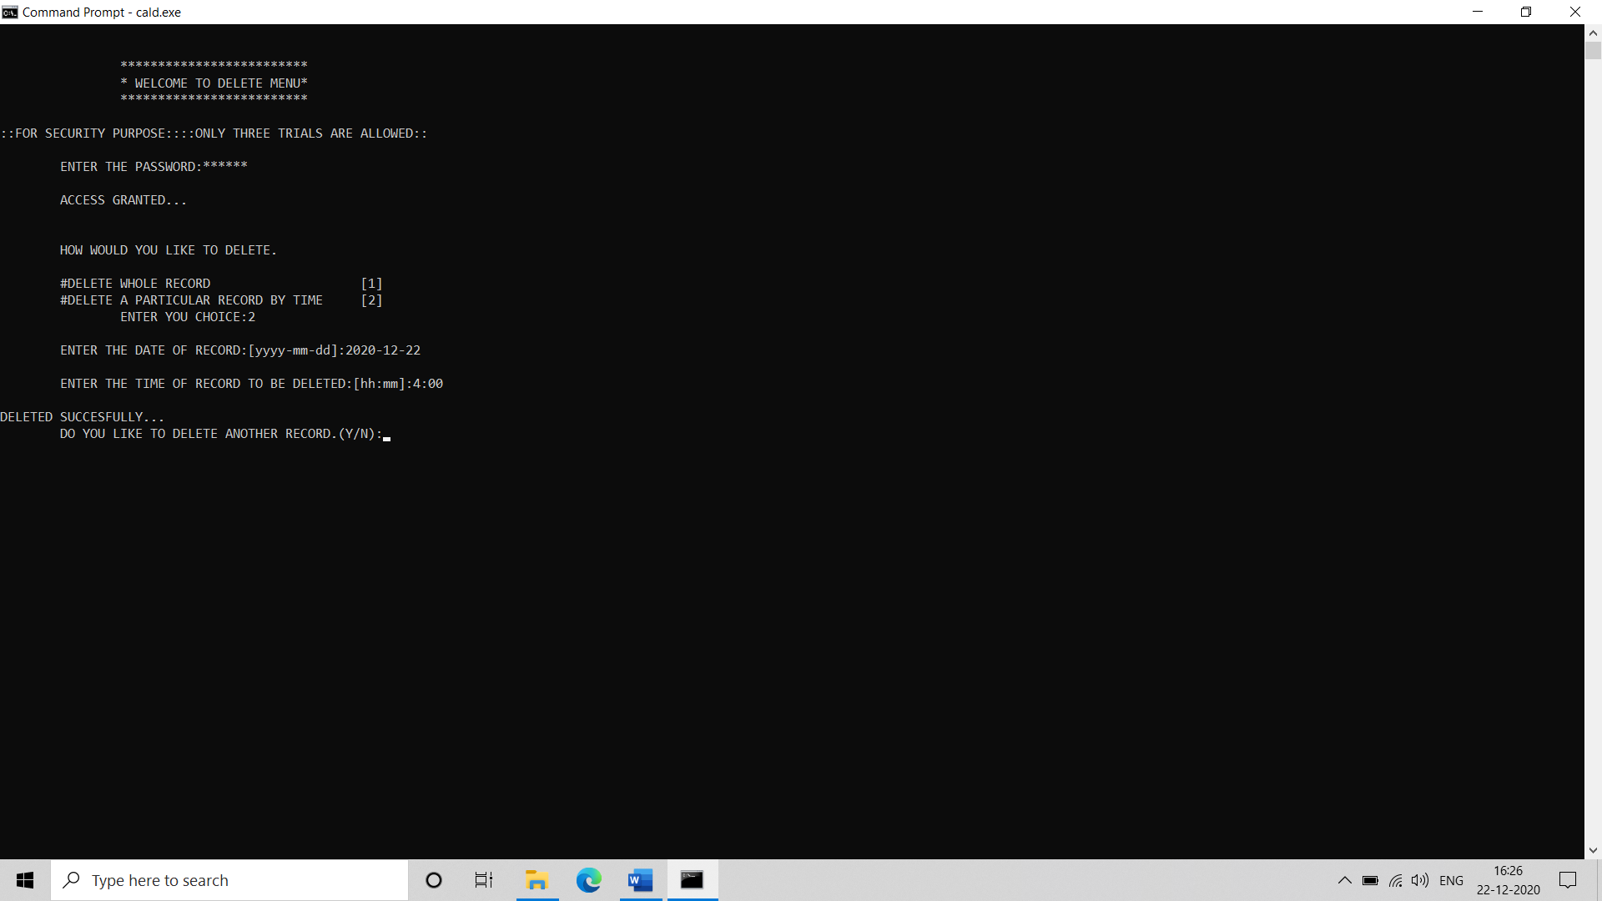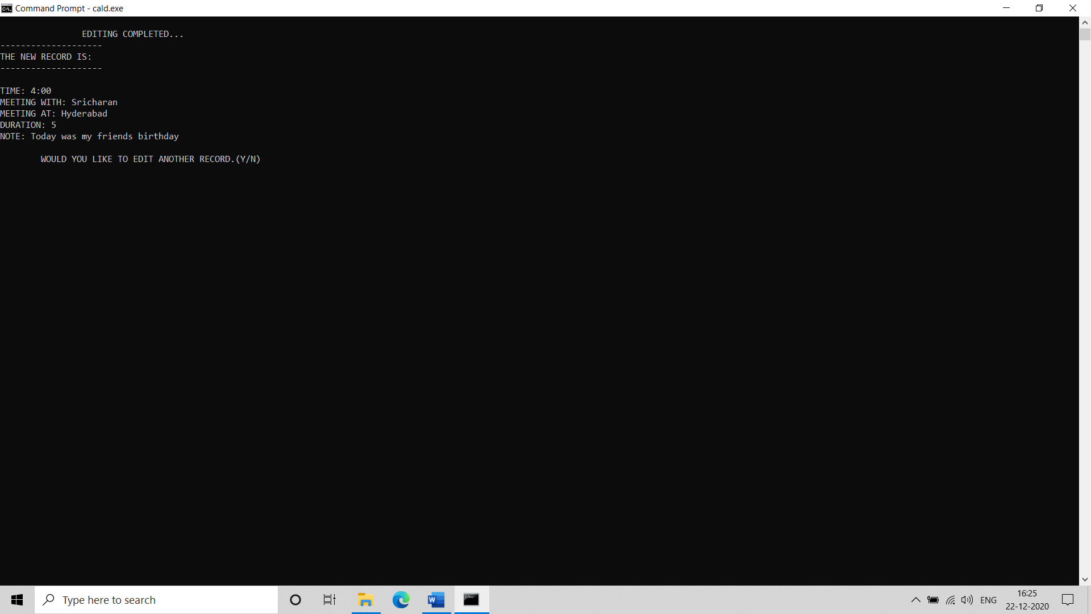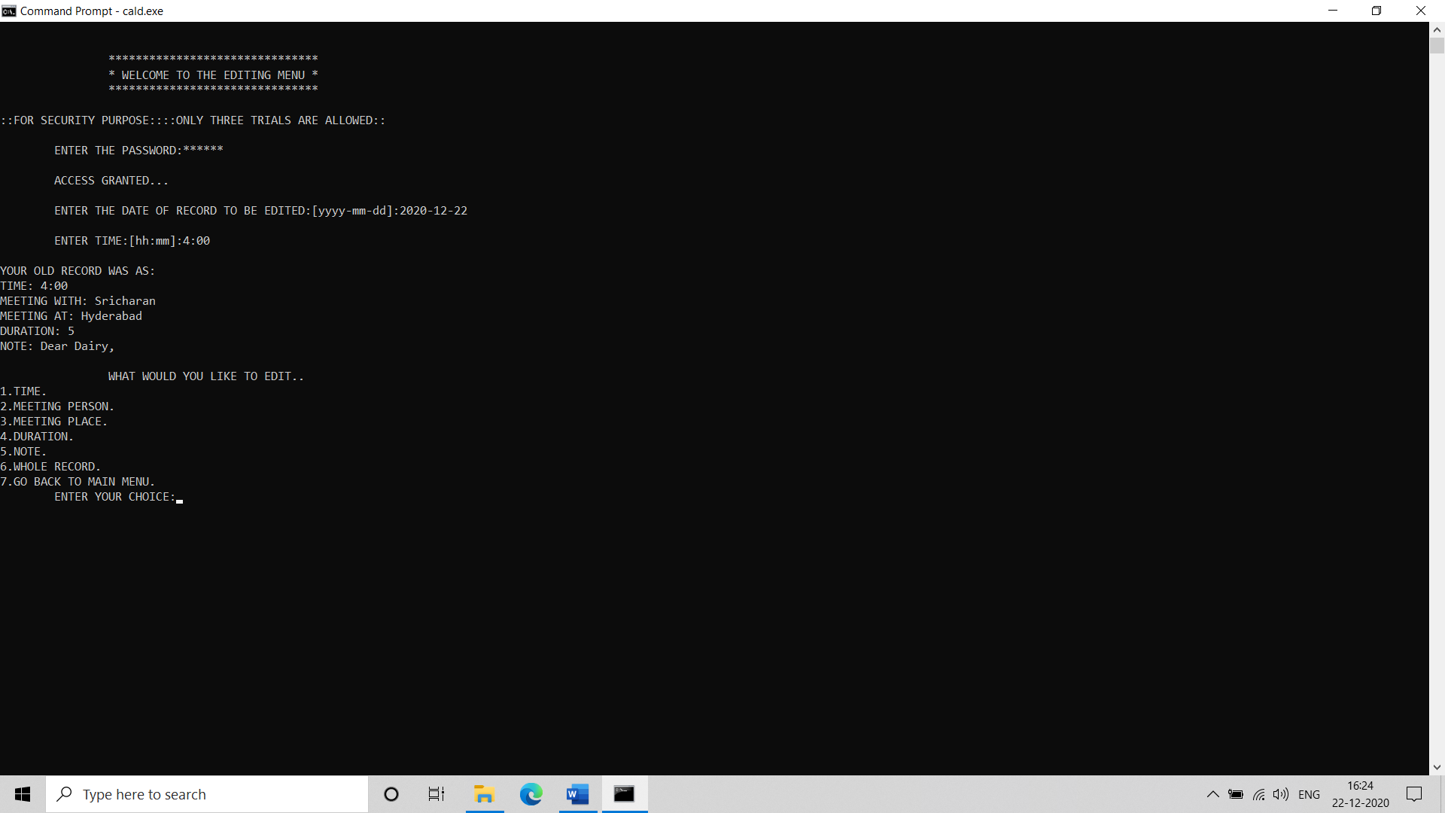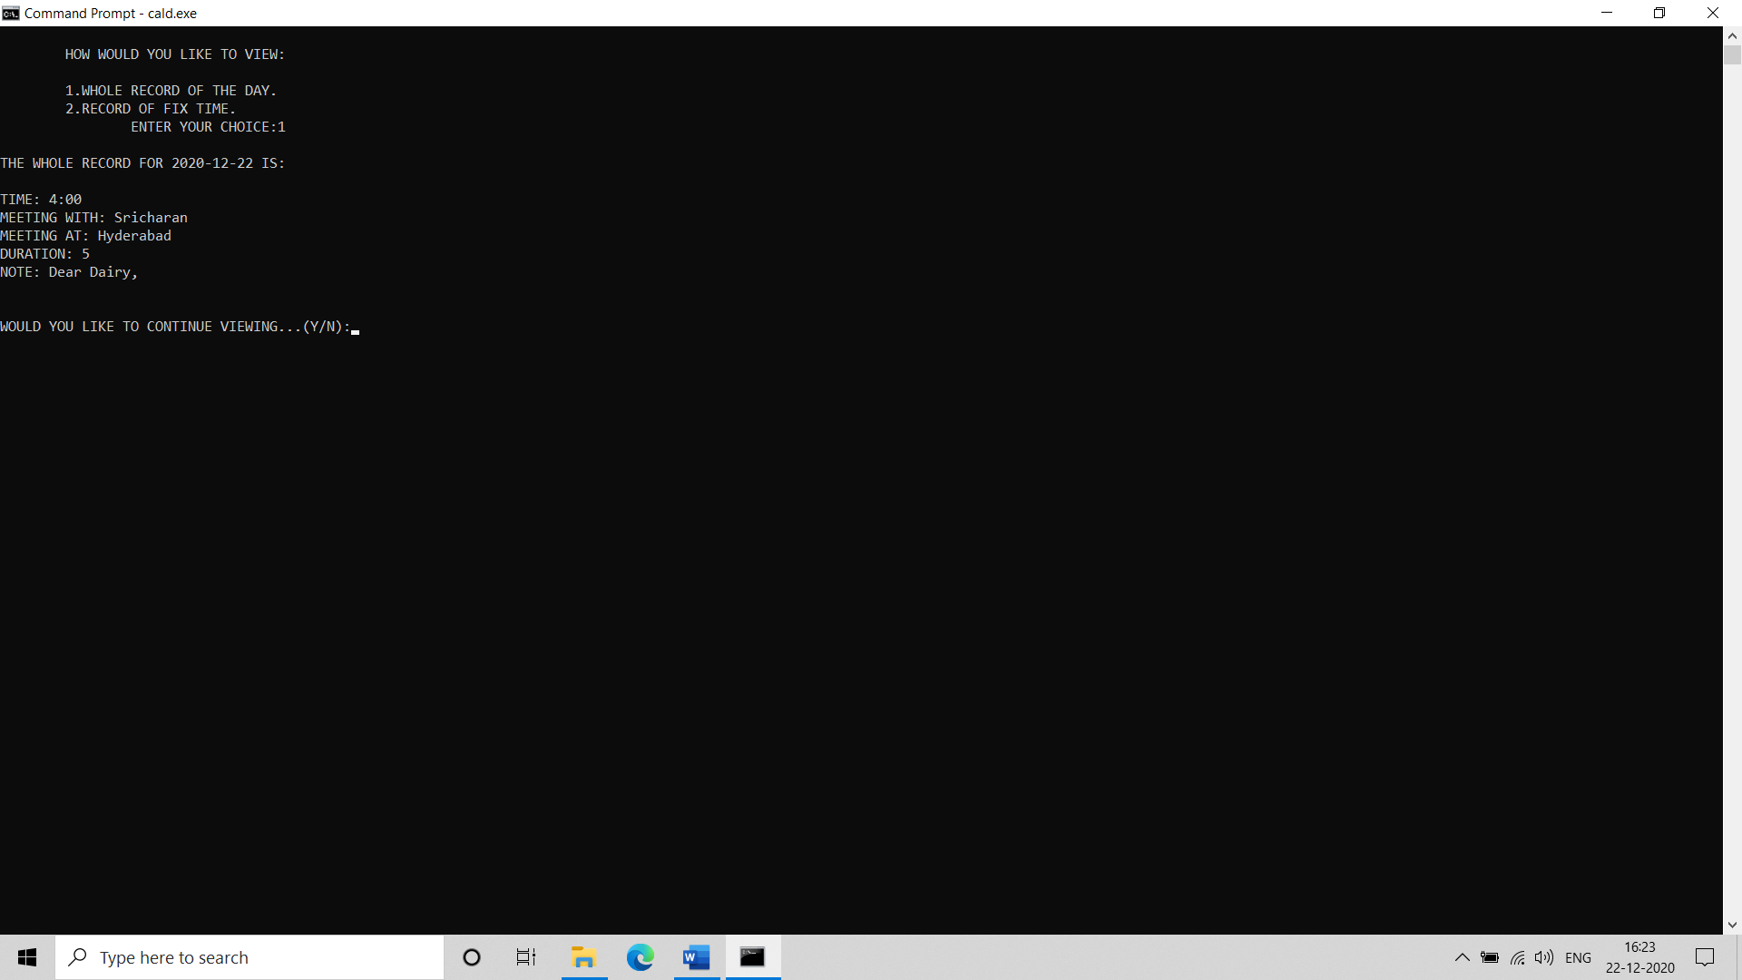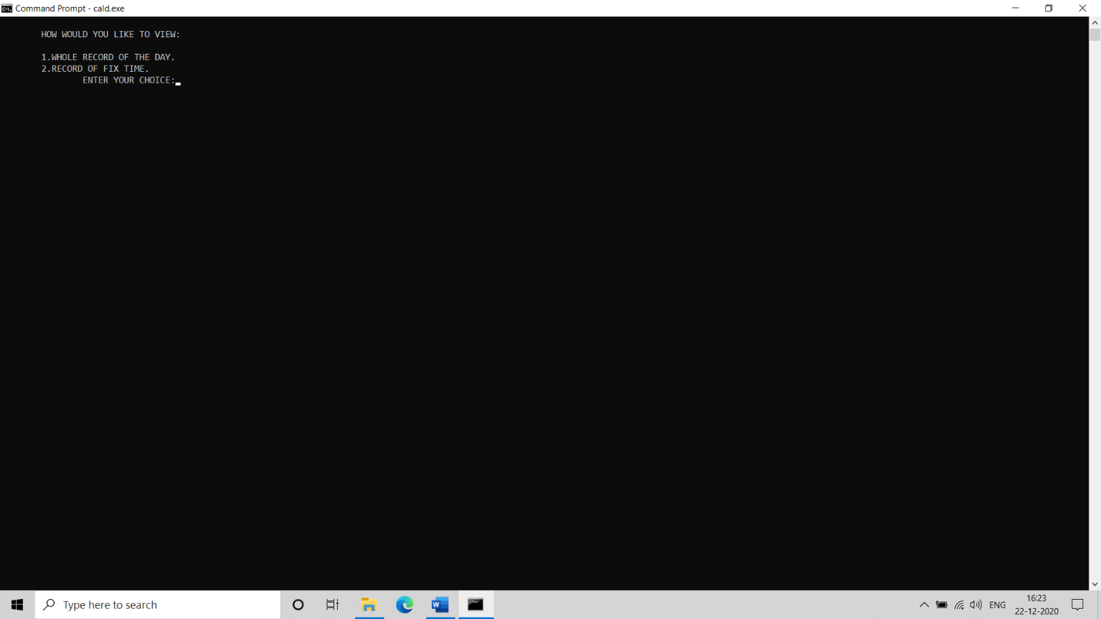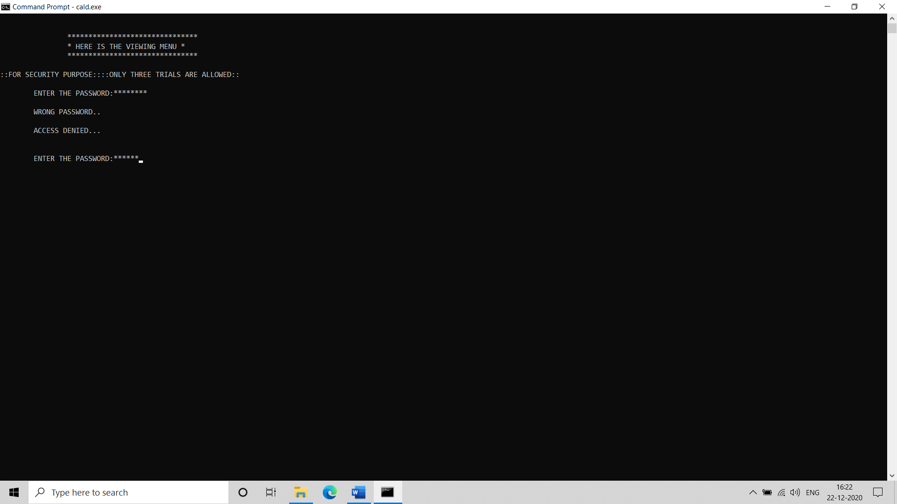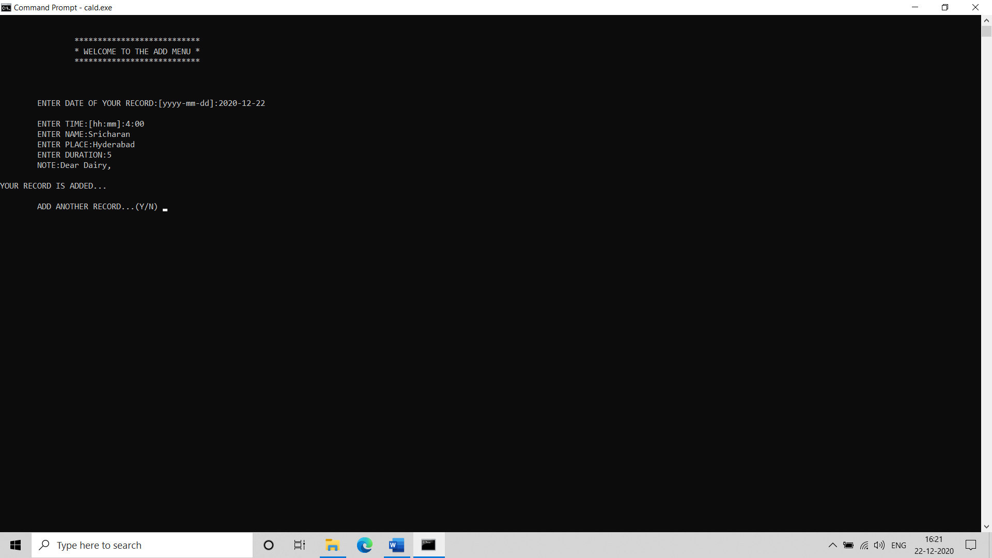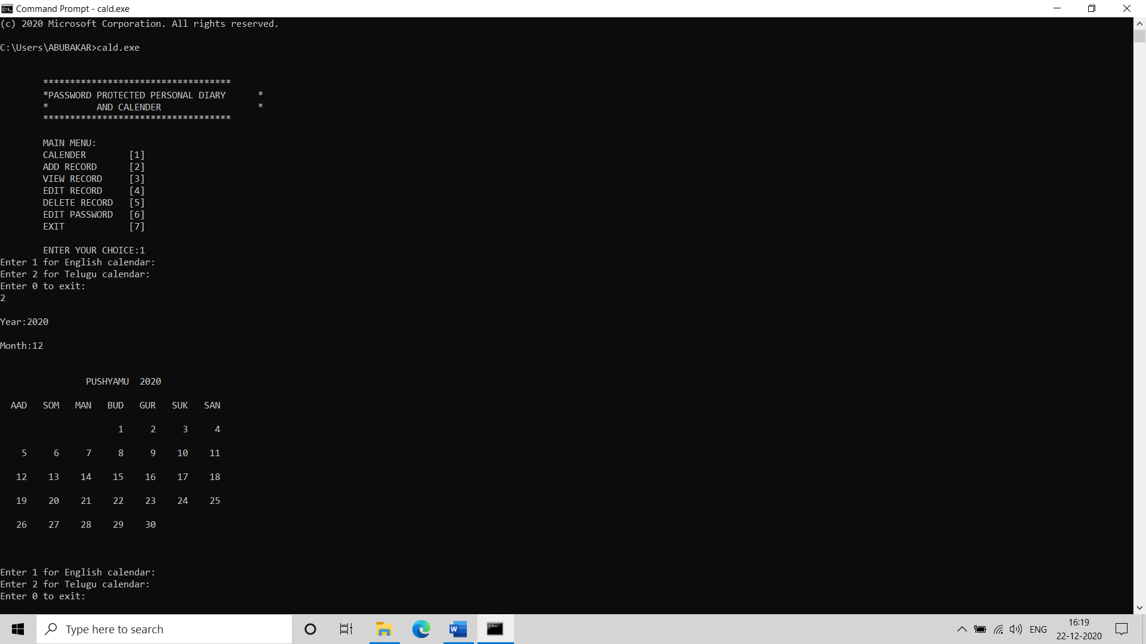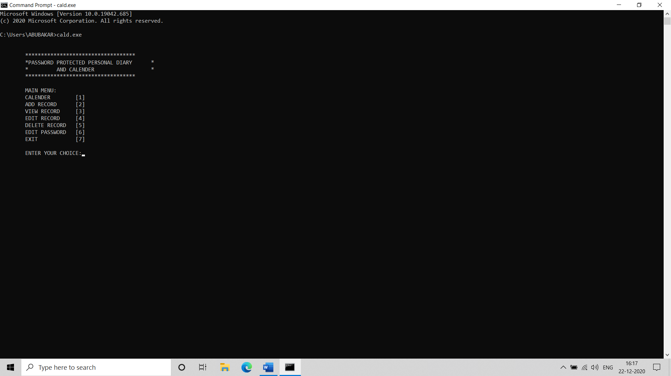

Github Profile:

Name : Mohammed Abu Bakar Siddiq

Roll No: 1602-19-737-083

Githhub profile: <https://github.com/ABSTwentyOne>

Name : Sajjanapu Sricharan

Roll No: 1602-19-737-112

Githhub Profile: https://github.com/sricharan112

TESTING

Testing is a method to check whether the actual product matches the expected requirements and to ensure that the product is defect-free. This process involves execution of various parts of the product either using manual or automated tools. The purpose is to identify errors, gaps or missing requirements in contrast to the actual requirements.

TEST PLAN

We approached testing our console application by analysing each module separately. First, we coded the requirements and then manually tested each feature present in the module to cover any gaps that might occur

Conclusion And Future Work:

To conclude, we have built a platform where we can use dairy and calender in single program with multiple languages. The intention behind our project was that we wanted to create an app which can be used for multiple purposes. We have successfully created , compiled and run the program.

In future by implementing more advanced security functions and graphics UI we can work on the project to develop for better version.

# References

Reading and Writing data from and into csv file

[**https://www.geeksforgeeks.org/csv-file-management-using-c/**](https://www.geeksforgeeks.org/csv-file-management-using-c/)

Stack Overflow (for debugging errors)

**https://stackoverflow.com/**